The January 2023, the PLSAS Executive Business Director gave a presentation that claimed school funding had not kept up with inflation. The slide presented is found below.

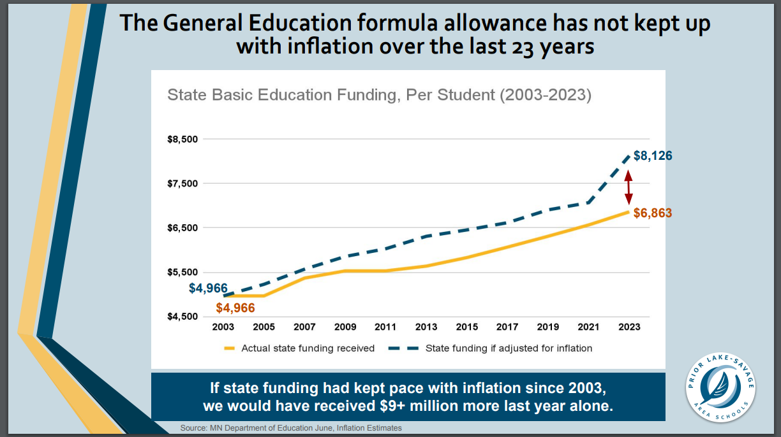

What the district was not clear with the presented material is that the General Education formula and associated revenue stream that comes from this formula is only one of many General Fund revenue streams that the district receives each year. The dollars represented above only make up roughly 60% of annual General Fund revenues. Also, I question why school districts has not run out of money if they went 23 years in which inflation outpaced revenue growth – wouldn’t you eventually run out of money and/or reduced a significant number of services the schools provided if this were the case?

A more accurate and less misleading depiction of whether school funding has outpaced inflation is to use total General Fund revenue (all revenue streams that make up the General Fund). See analysis below:

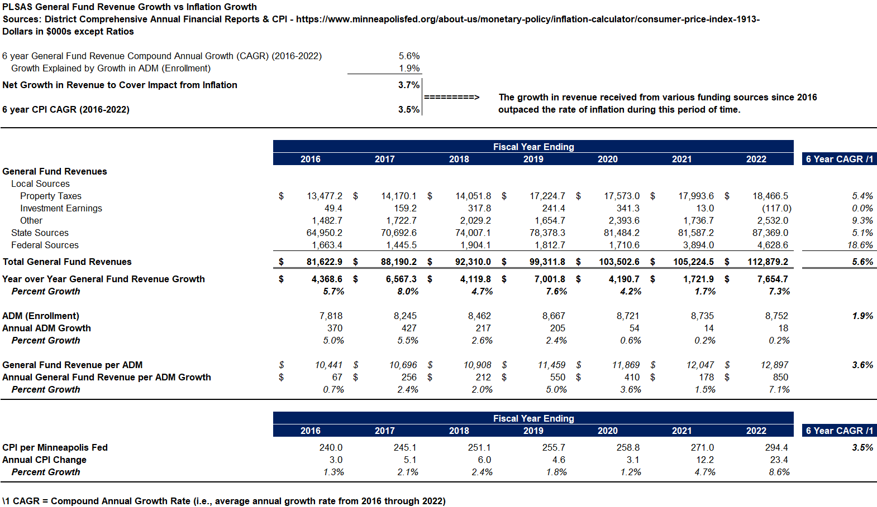

A few observations related to the table above:

- Our General Fund revenue has grown 5.6% compounded annual since 2016.
- 1.9% of the 5.6% revenue growth can be attributed to our enrollment growth.
- That leaves 3.7% net revenue growth (5.6% minus 1.9%) not due to enrollment.
- This 3.7% net revenue growth is higher than the average annual CPI (inflation) growth rate of 3.5% since 2016.
- I only went back to 2016 – no reason to go back to 2003 like the district did other than for dramatic effects – not sure if district is trying to scare community that something wrong has gone on for so long.

This analysis shows, that when you look at all revenue streams, our district’s General Fund revenue has outpaced inflation – even during the past two years in which inflation has been very high.

Some general comments related to how inflation and the district’s expenditures are impacted include:

- Roughly 60% of the district’s expenditures are salary related. Most of our union contracts have wage increases that are much lower than the current rate of inflation (around 2%-3% annual wage increases)
- So even though inflation has been high the past two years, 60% of our expenditures will not be materially impacted while the current contracts have been in place.
- The Governor’s proposed budget released the week of January 22nd includes the following:
  - a 4% increase in the general education formula next year – this would result in PLSAS receiving roughly $275 more per student, or $2.4M of increased annual on-going revenue.
  - Reduce the special education funding gap by 50%. Our 2020-21 (most recent info available) special education funding gap per MDE was $5.9M. That means, if the Governor is successful, we can expect an additional $2.95M in annual, ongoing funding related to this objective.

Just these two items above equate to roughly $5.35M more in annual funding PLSAS will receive beginning in 2023-24 fiscal year. With a democrat house and senate, the odds are good the Governor gets his way. This additional funding will remove any need for the district to come out and ask for an increased in the local tax levy in 2023 or 2024.

I also get concerned whenever I hear the district comparing ours to the 7-county metro area averages. We shouldn’t be comparing ourselves with school districts such as Minneapolis or St. Paul or any other larger, more urban districts since our student demographics are so much different that the large, urban districts. A healthy portion of state funding we receive is driven by demographics and other factors which hurt us (we get less) when compared to more urban communities – such as:

- We have far fewer English Learners, so we get less EL revenue from the state.
- We have far fewer students that need remedial instruction, so we get less compensatory revenue from the state.
- We have far fewer special education students, so we get less special education revenue from the state.
- We have far fewer students that get free or reduced lunch and/or are homeless so we do not get subsidies from the state related to those factors.
- I believe we have newer facilities than some of the other more urban districts, so we receive less revenue for operating maintenance and associated costs from the state.

Net/Net - It only makes sense that if we have less of the above, then we wouldn’t incur the expense associated with those issues and we shouldn’t expect to receive those levels of revenue that say, a Minneapolis or St. Paul school district would receive.

Do we have a lower operating levy than other school districts? The answer to that question is yes – but a big reason for that is that our tax base doesn’t have a significant amount of businesses that operate within our district where we can spread the taxes out to - much of the burden of our operating levy must fall upon residents vs business which hurts our ability to raise local residential property taxes to fund our schools.

In the District Financial Information section of the Lakers for Change website, you will find two files that show the following Revenue and Expense per ADM (students) comparisons to similar-sized ISDs, Scott County ISDs and the entire state. These comparisons are more appropriate than comparing ourselves with the 7-county metro area.

